MEMORY CARD MATCHING GAME USING PYTHON

AIM
To design and develop an interactive Memory Card Matching Game using Python Tkinter. The player flips two cards at a time to find matching pairs. The game tracks the number of moves, hides unmatched cards, identifies when all pairs are found, and provides restart and exit options.

FEATURES
- Agraphical board containing 16 cards (8 matching pairs).
- Mouse-click controls to reveal cards.
- Automatic matching and hiding of unmatched cards.
- Move counter and win message.
- Restart Game and Exit buttons.

PROCEDURE
- Import the Tkinter and random libraries.
- Create the main window and set its title, background, and size behaviour.
- Display the game heading, instructions, move counter, card board, and control buttons.
- Create a list containing eight symbols twice, then shuffle it to place the cards randomly.
- Create sixteen buttons in a four-by-four grid and initially show a question mark on each card.
- When a card is clicked, reveal its symbol and store its position.
- When two cards are revealed, increase the move counter and compare their symbols.
- If the symbols match, keep both cards visible and mark them as matched.
- If the symbols do not match, wait briefly and hide both cards again.
- When all sixteen cards are matched, display the win message.
- Implement Restart Game to shuffle a new set of cards and reset the counter.
- Implement Exit to close the application, then run and test the program.

PROGRAM CODE
import tkinter as tk import random
# Game settings
CARD_SYMBOLS = ["A", "B", "C", "D", "E", "F", "G", "H"]
CARD_BACK = "?"
CARD_WIDTH = 90
CARD_HEIGHT = 75 CARD_GAP = 10
class MemoryCardGame: def __init__(self, root):
self.root = root
self.root.title("MEMORY CARD MATCHING GAME")
self.root.resizable(False, False) self.root.configure(bg="#172554")
tk.Label( root,
text="MEMORY MATCH",
font=("Arial Black", 22), bg="#172554", fg="white" ).pack(pady=(12, 4))
self.info_label = tk.Label( root, text="Find all matching pairs!", font=("Arial", 13, "bold"), bg="#172554", fg="#FACC15"
)
self.info_label.pack(pady=4)
self.moves_label = tk.Label(
root, text="Moves: 0", font=("Arial", 12, "bold"), bg="#172554", fg="white"
)
self.moves_label.pack(pady=3)
self.board_frame = tk.Frame(root, bg="#172554") self.board_frame.pack(padx=15, pady=10)
button_frame = tk.Frame(root, bg="#172554") button_frame.pack(pady=(2, 14))
tk.Button( button_frame, text="RESTART GAME", font=("Arial", 10, "bold"), bg="#22C55E", fg="black", command=self.restart ).pack(side="left", padx=8)
tk.Button( button_frame, text="EXIT", font=("Arial", 10, "bold"), bg="#EF4444", fg="white", command=root.destroy ).pack(side="left", padx=8)
self.restart()
def restart(self):
self.cards = CARD_SYMBOLS * 2 random.shuffle(self.cards) self.buttons = [] self.flipped = [] self.matched = set() self.moves = 0 self.locked = False
self.info_label.config(text="Find all matching pairs!") self.moves_label.config(text="Moves: 0")
for widget in self.board_frame.winfo_children(): widget.destroy()
for index in range(len(self.cards)):
button = tk.Button( self.board_frame, text=CARD_BACK, font=("Arial Black", 18), width=4,
height=2, bg="#2563EB",
fg="white",

activebackground="#60A5FA", command=lambda i=index: self.flip_card(i)
)
button.grid( row=index // 4, column=index % 4, padx=CARD_GAP // 2, pady=CARD_GAP // 2
)
self.buttons.append(button)
def flip_card(self, index):
if self.locked or index in self.matched or index in self.flipped: return
self.buttons[index].config( text=self.cards[index], bg="#FACC15", fg="#172554"
)
self.flipped.append(index)
if len(self.flipped) == 2:
self.moves += 1 self.moves_label.config(text=f"Moves: {self.moves}")
first, second = self.flipped if self.cards[first] == self.cards[second]: self.matched.update((first, second)) self.buttons[first].config(bg="#22C55E", fg="black") self.buttons[second].config(bg="#22C55E", fg="black")
self.flipped = []
if len(self.matched) == len(self.cards):
self.info_label.config(
text=f"You won in {self.moves} moves!"
) else:
self.locked = True self.root.after(800, self.hide_cards) def hide_cards(self): for index in self.flipped: self.buttons[index].config( text=CARD_BACK, bg="#2563EB", fg="white"
)
self.flipped = [] self.locked = False
# Main application root = tk.Tk() game = MemoryCardGame(root) root.mainloop()

OUTPUT
START SCREEN
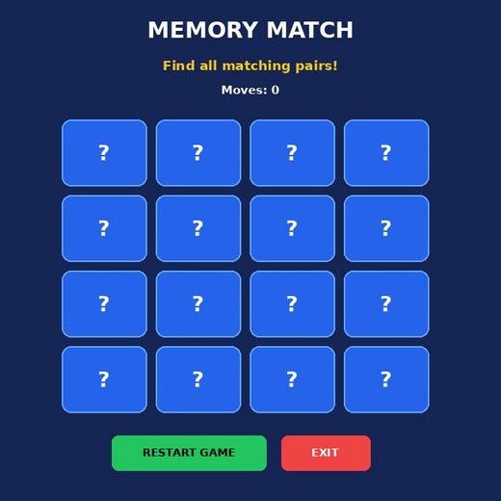
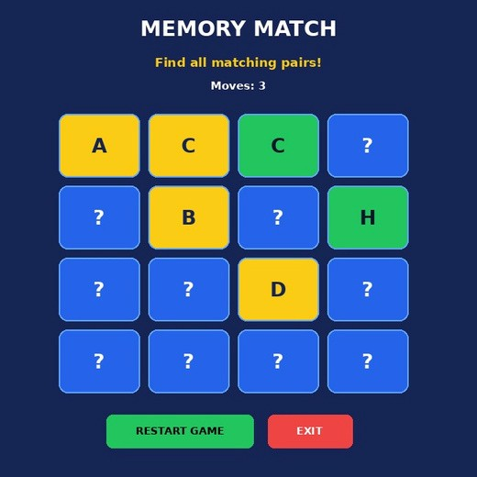
Game in progress. Revealed cards are yellow, matched cards are green, and hidden cards are blue.
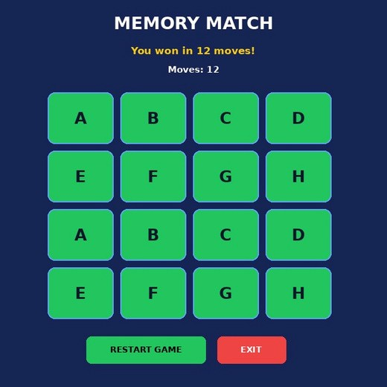
completed game showing the win message and final move count

RESULT

Thus, A Memory Card Matching Game was developed using Python Tkinter. The game includes a graphical interface, random card arrangement, mouse-based interaction , pair matching, move counting, unmatched-card handling, win detection, restart functionality, and exit controls. The project demonstrates GUI design, event handling, lists, randomisation, loops, and conditional statements.

